Project Design Phase-II
Technology Stack (Architecture & Stack)

Date | 3 OCTOBER 2026
Team ID | SWTID-2026-5226
Project Name | Import Data using Transform Maps (Spreadsheet)
Maximum Marks | 4 Marks

Technical Architecture:
The Deliverable shall include the architectural diagram as below and the information as per the table1 & table 2
Project: Import Data using Transform Maps (Spreadsheet)
Reference: https://www.servicenow.com/docs

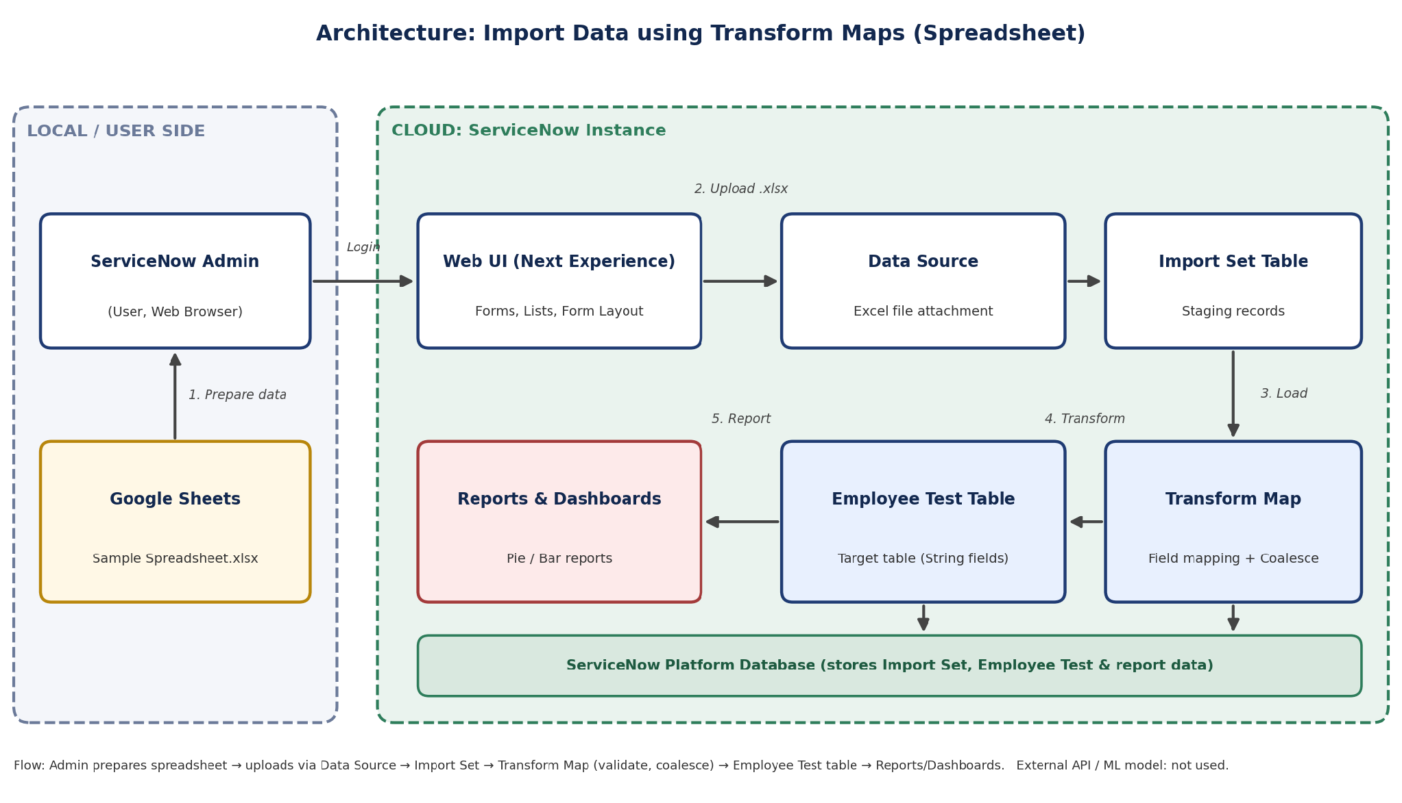

Table-1 : Components & Technologies:
S.No | Component | Description | Technology
 | User Interface | ServiceNow Web UI used by the administrator to create the table, data source, import set, transform map and reports; Google Sheets used to prepare the source data. | ServiceNow Platform UI (Forms, Lists, Form Layout), Google Sheets
 | Application Logic-1 | Import Set & Data Source: the Sample Spreadsheet.xlsx file is attached to a Data Source and loaded into the Import Set staging table. | ServiceNow Import Sets, Data Source (Excel)
 | Application Logic-2 | Transform Map: maps source (import set) fields to the Employee Test target fields, then transforms and validates the data. | ServiceNow Transform Map, Field Maps
 | Application Logic-3 | Coalesce: one unique field map is set to Coalesce = True so that existing records are updated and duplicate records are avoided. | ServiceNow Coalesce (Field Map)
 | Database | Employee Test table with the fields Employee ID, Employee Name, Email, Department and Location (Type: String). | ServiceNow tables (relational platform database)
 | Cloud Database | Database service hosted on the ServiceNow cloud instance that stores the import set, Employee Test and report data. | ServiceNow Cloud Platform Database
 | File Storage | Sample Spreadsheet.xlsx is downloaded from Google Sheets and uploaded as an attachment to the Data Source. | ServiceNow Attachments, Local Filesystem
 | External API-1 | Google Sheets is used only to create and download the sample data; no API integration is required. | Google Sheets (manual .xlsx export)
 | External API-2 | Not applicable: no second external API is used in this project. | Not applicable
 | Machine Learning Model | Not applicable: no machine learning model is used in this project. | Not applicable
 | Infrastructure (Server / Cloud) | Application Deployment on Cloud (ServiceNow instance)  Local Server Configuration: Not required; only a web browser is needed.  Cloud Server Configuration: ServiceNow-hosted instance with the Import Sets, Transform Maps, Tables and Reports modules. | Cloud (ServiceNow Instance)

Table-2: Application Characteristics:
S.No | Characteristics | Description | Technology
 | Open-Source Frameworks | Platform-native, low-code ServiceNow components are used, so no external open-source framework is needed. | ServiceNow Import Sets and Transform Maps; Open XML (.xlsx) file format
 | Security Implementations | Role-based access control restricts who can import data, edit transform maps and view tables and reports; users must log in to the instance. | ServiceNow roles & ACLs, user authentication, HTTPS (TLS)
 | Scalable Architecture | Layered cloud architecture (UI, logic, database); the same data source and transform map can be reused for larger files and new fields. | ServiceNow multi-tier cloud platform
 | Availability | The application runs on the cloud-hosted ServiceNow instance, so import, transform and reporting are available whenever the instance is available. | ServiceNow Cloud
 | Performance | Data is first loaded into a staging import set table and then transformed in one run; coalesce avoids duplicate records, and reports are built directly on the Employee Test table. | Import Set staging table, Transform Map, ServiceNow Reports

References:
https://c4model.com/
https://developer.ibm.com/patterns/online-order-processing-system-during-pandemic/
https://www.ibm.com/cloud/architecture
https://aws.amazon.com/architecture
https://medium.com/the-internal-startup/how-to-draw-useful-technical-architecture-diagrams-2d20c9fda90d

